# User guide

## Production Monitoring

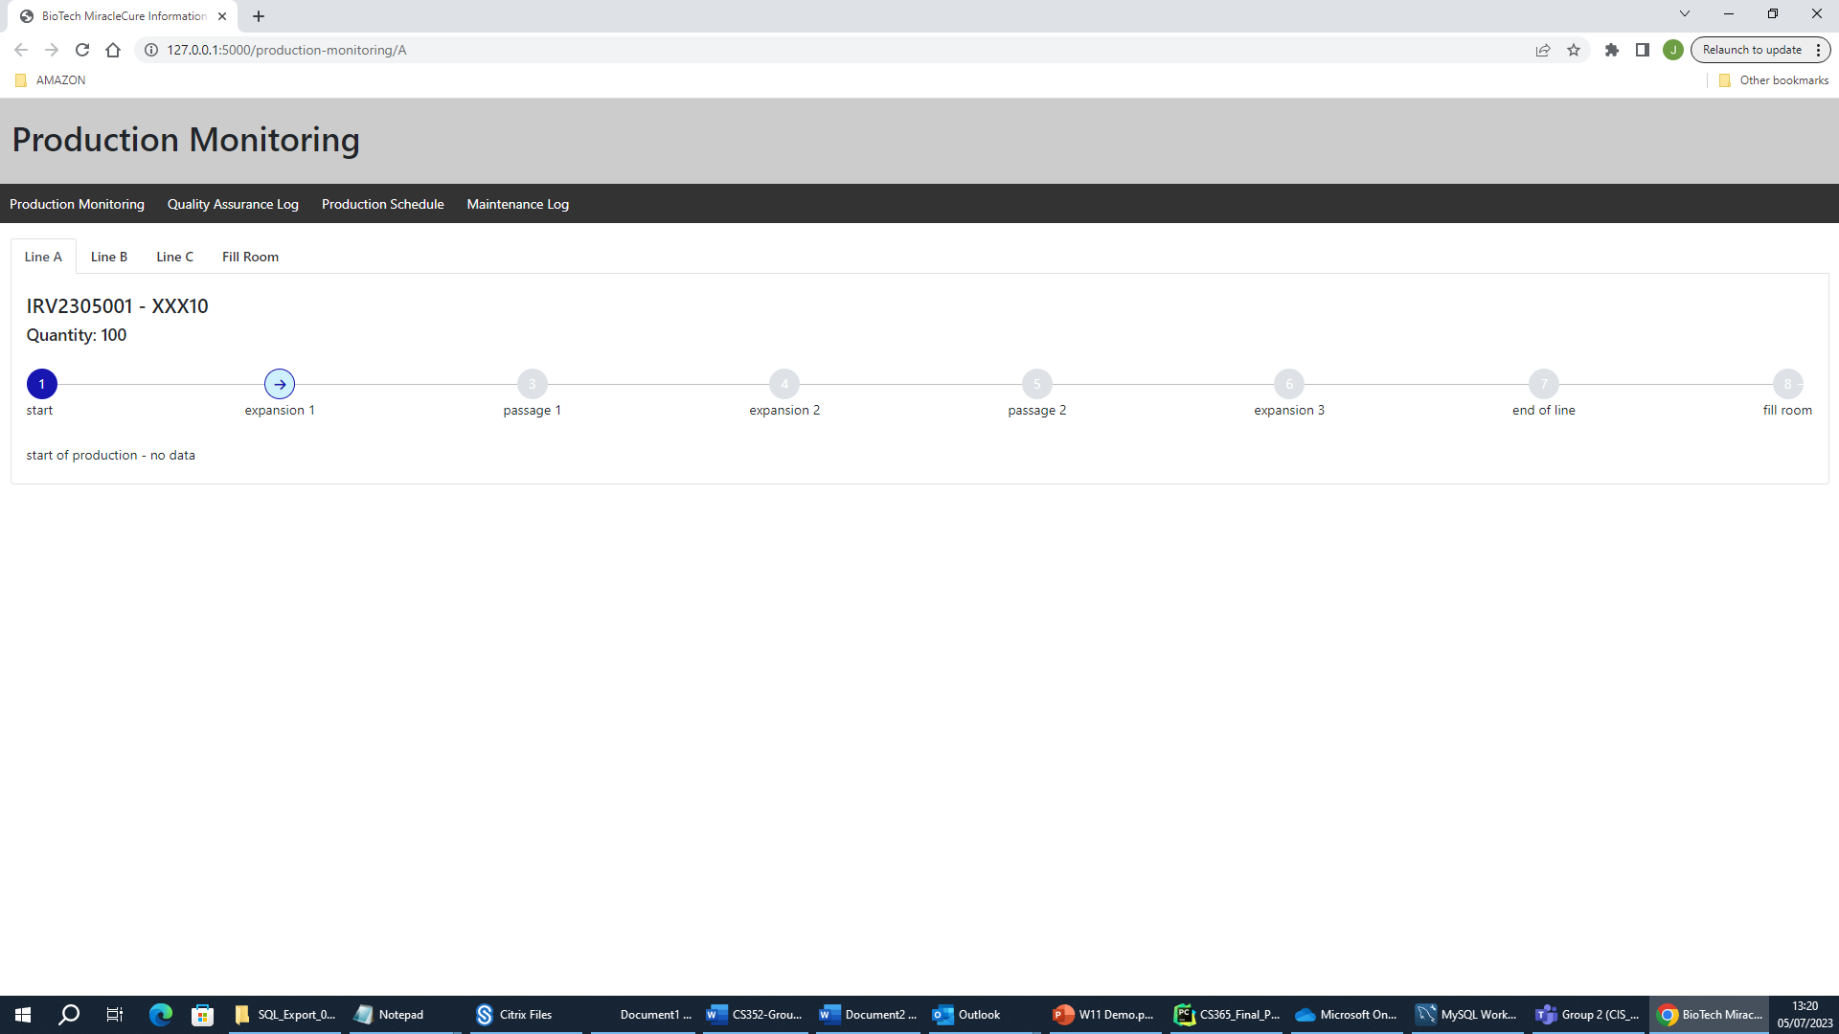

The purpose of the production monitoring page is to allow users to monitor the status of each production line (A,B,C) and the fill room. Whether the production line is in maintenance or currently has a batch in production.

A typical batch production workflow would look as follows, which can be stepped through by an operator to allow for monitoring of this batch production.

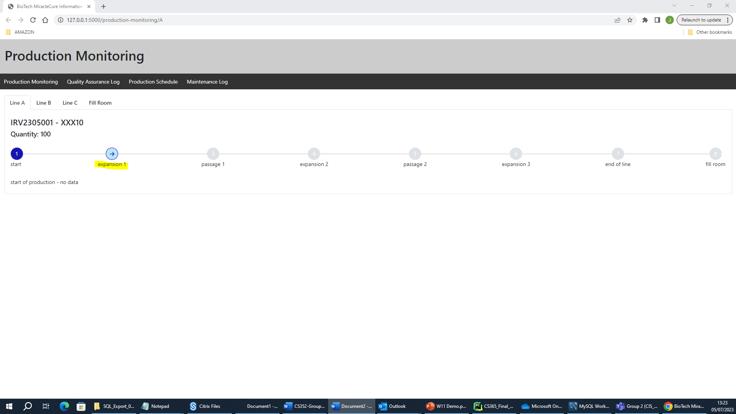

### Expansion

During an expansion phase an operator can update the monitoring details for each flask by clicking the update monitor button.

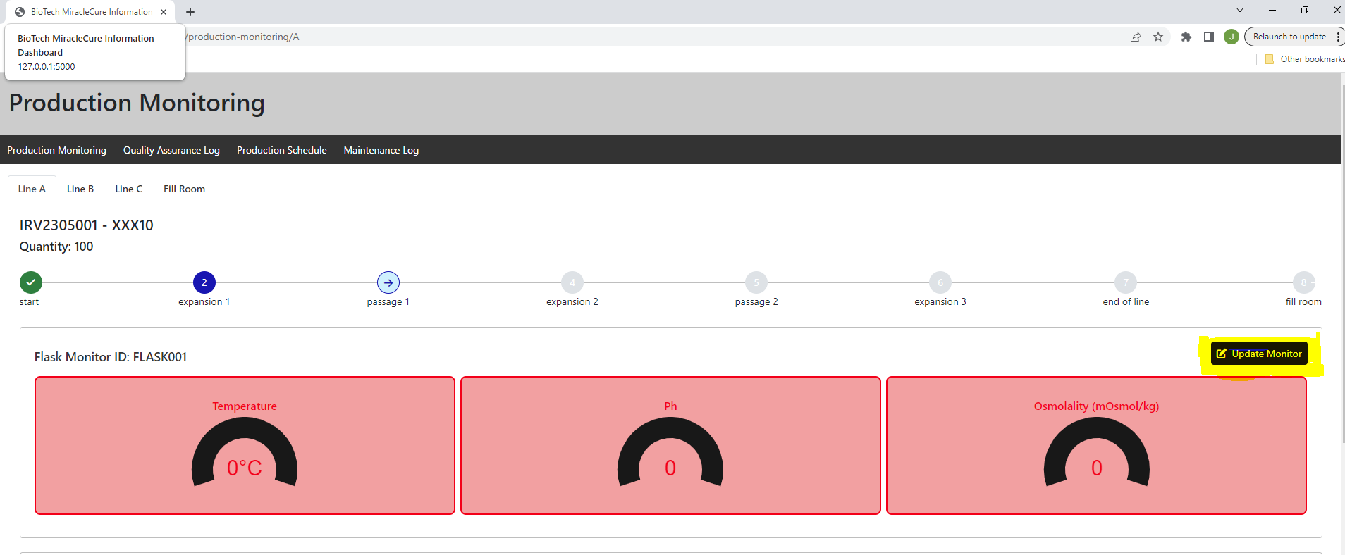

After selecting this button, the operator is prompted to update the expansion monitoring conditions for the respective flask.

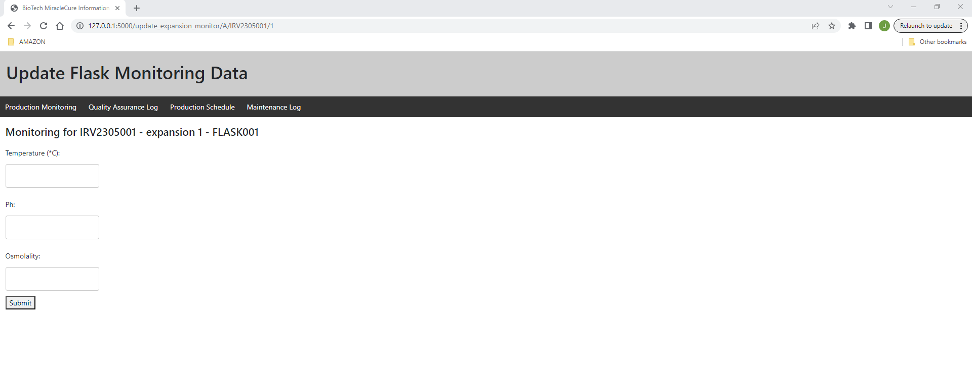

After the monitoring information is entered the monitoring dials will update on the production line.

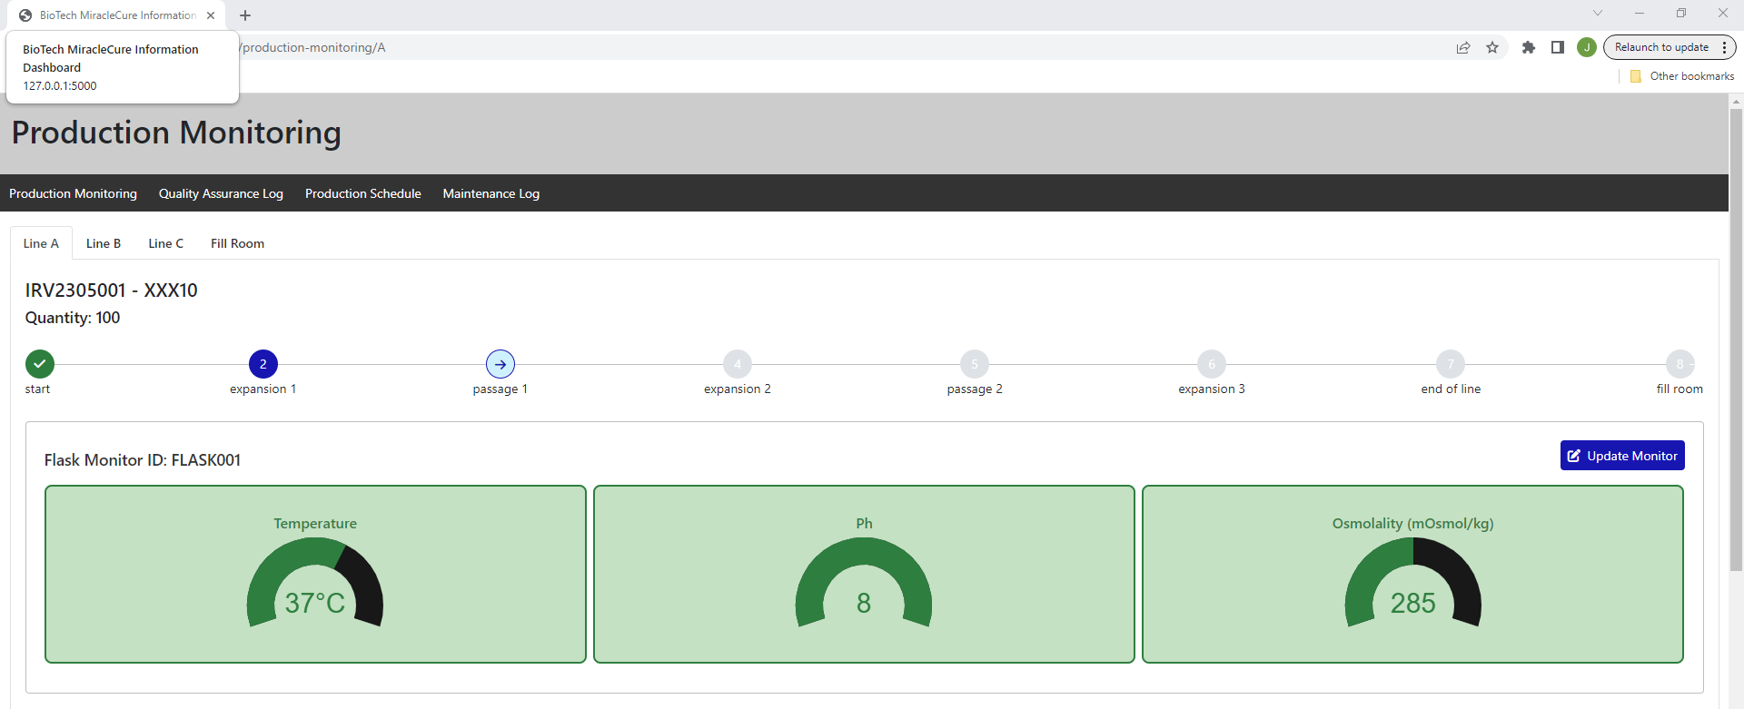

### Passage

During a passage stage. The operator can monitor the conditions passage conditions through updating them manually. As highlighted below.

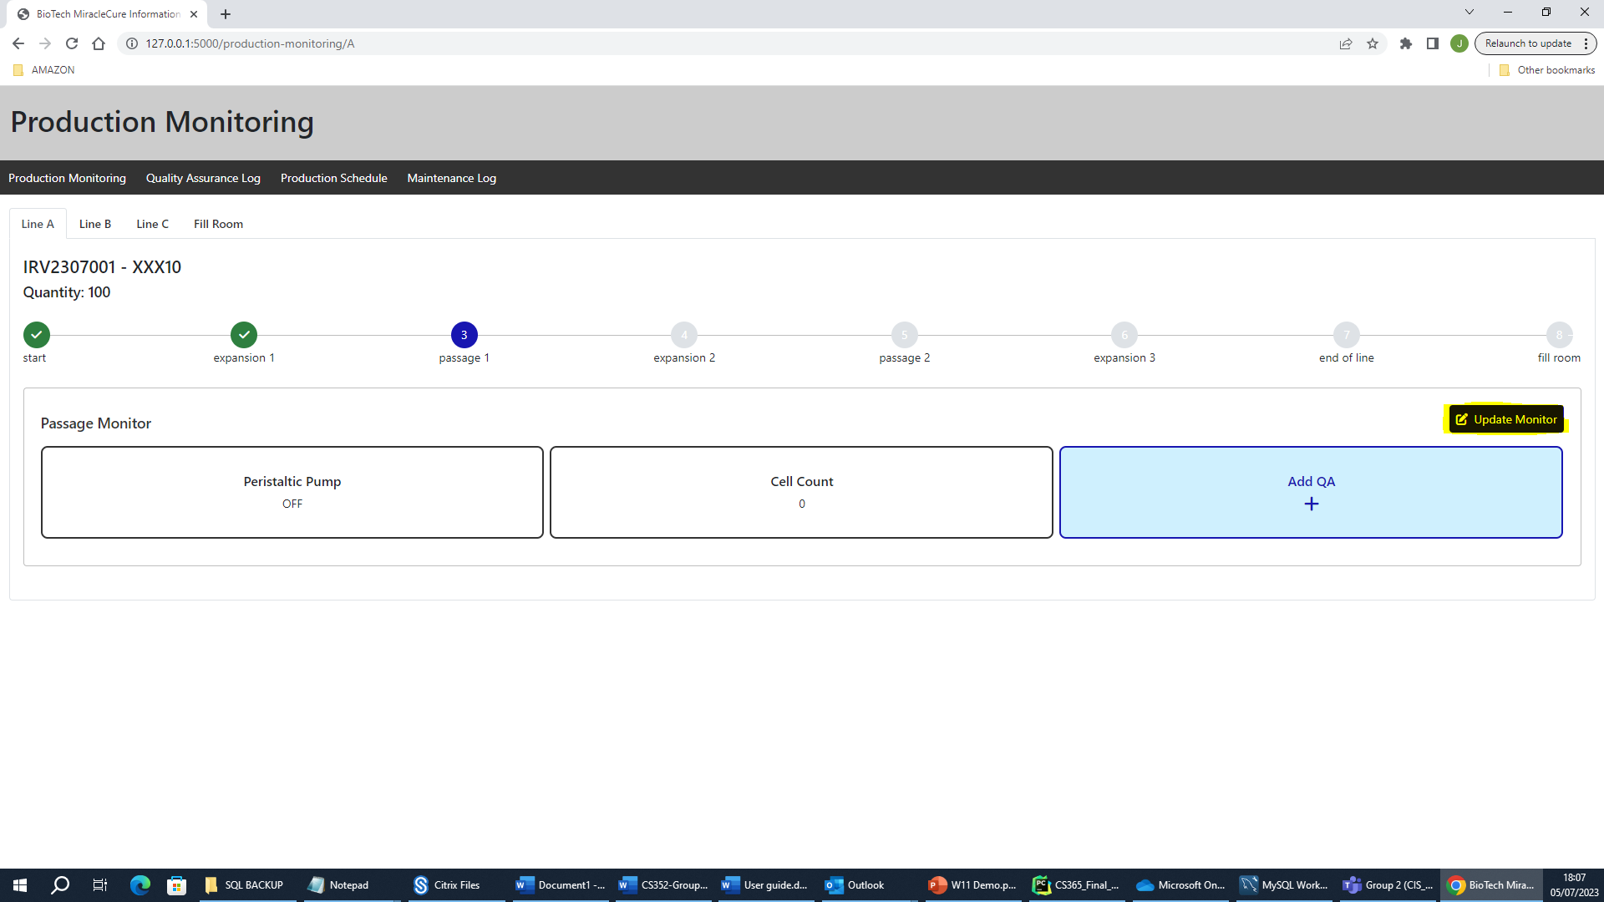

Which displays a form to manually update these conditions.

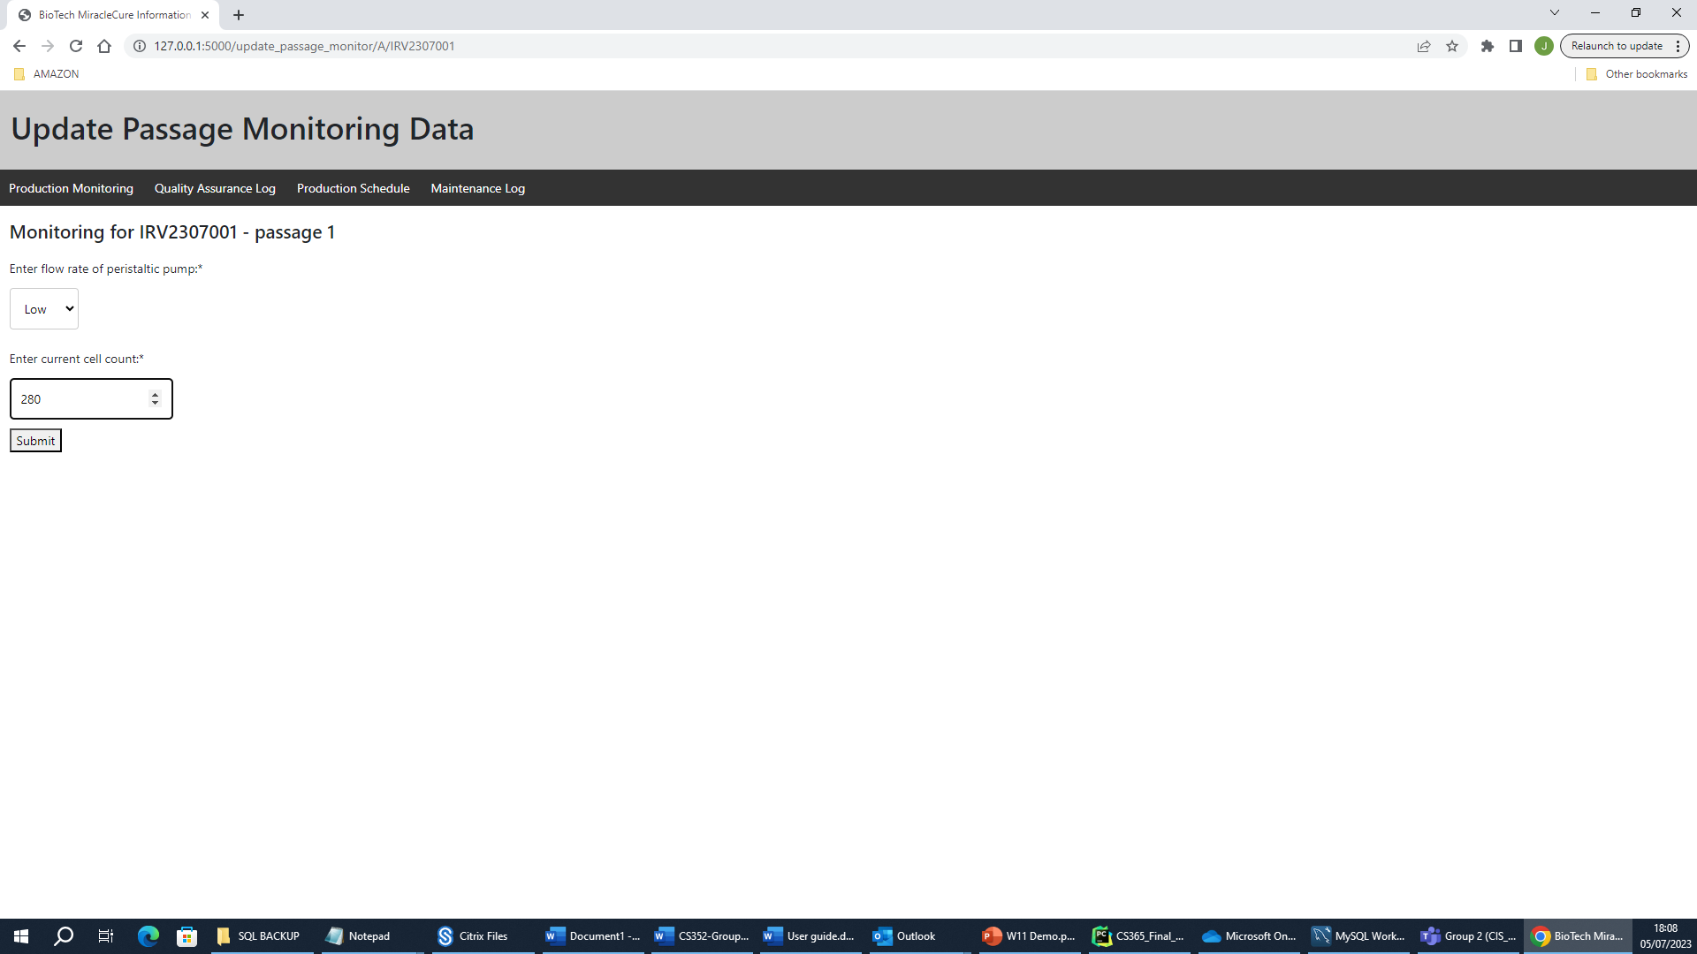

After submitting this, the passage monitoring data is updated on the production line.

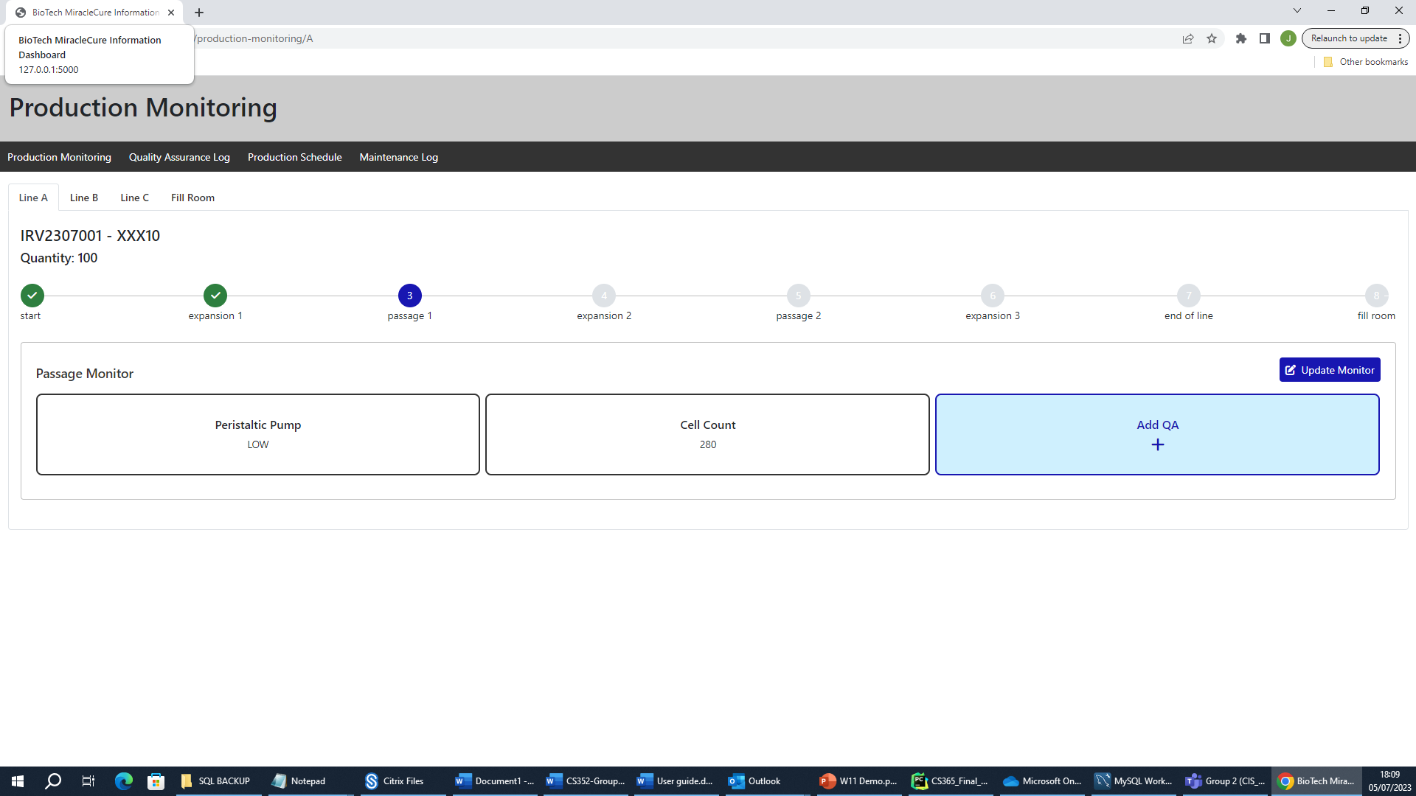

The operator can also perform a QA test on the given passage stage by clicking on the Add QA button.

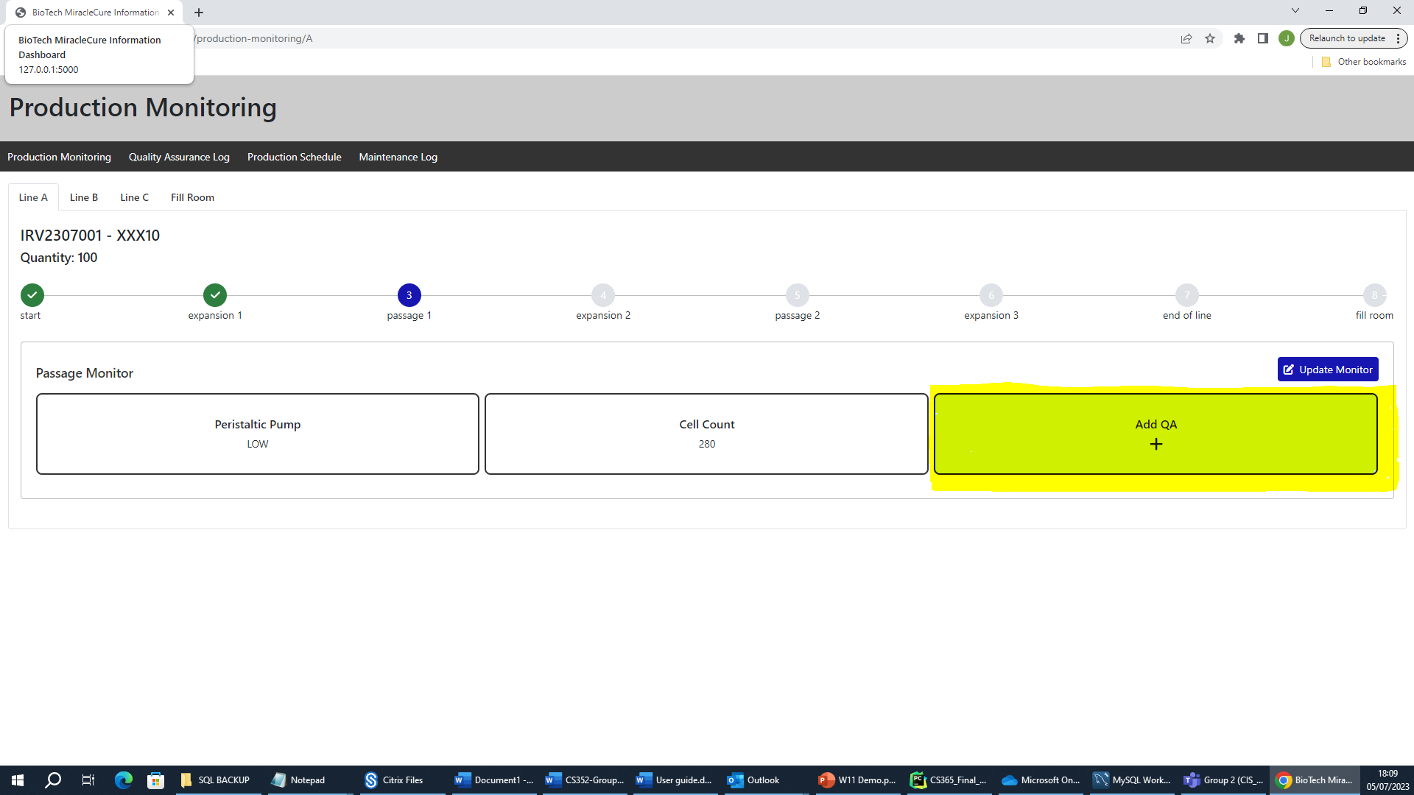

The operator can then enter the QA test results gathered manually which the system will analyse against the product type to determine if the QA test passes or fails.

If the results entered do not meet the pass requirements for QA, the passage will fail and display a list of reasons as to why this happened. It will also not allow the batch to progress further through the production line with the next button being diabled.

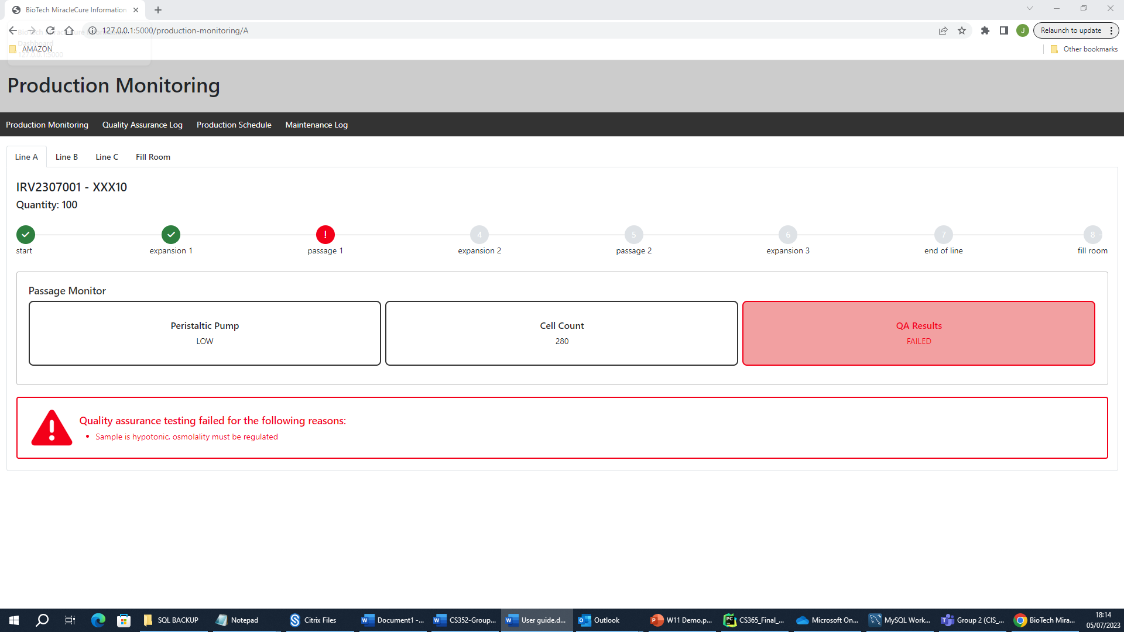

If the batch passes QA on the other hand, it will show the below and allow the user to progress the batch production to the next stage.

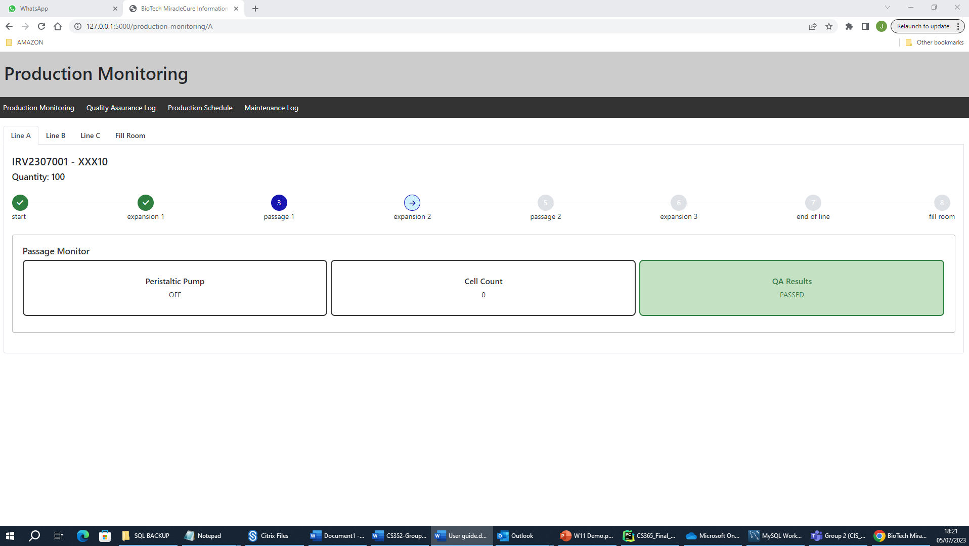

### Fill Room

After a batch has gone through the production process (successfully passed QA at each stage) it will go into the fill room; at which stage the production line monitor will prompt the user of this and give some detail for when the next production activity will start.

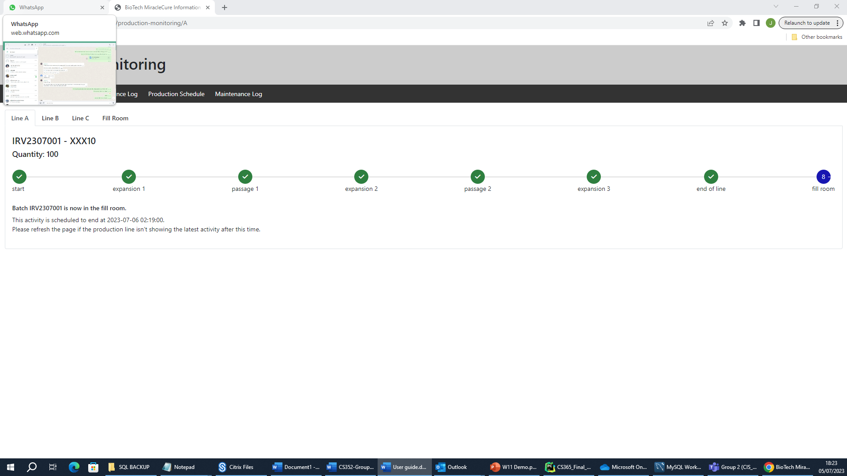

## Quality Assurance Log

The quality assurance log is not yet implemented but the intention of this is to display all batches from the previous month with their corresponding QA data from each stage in the production line.

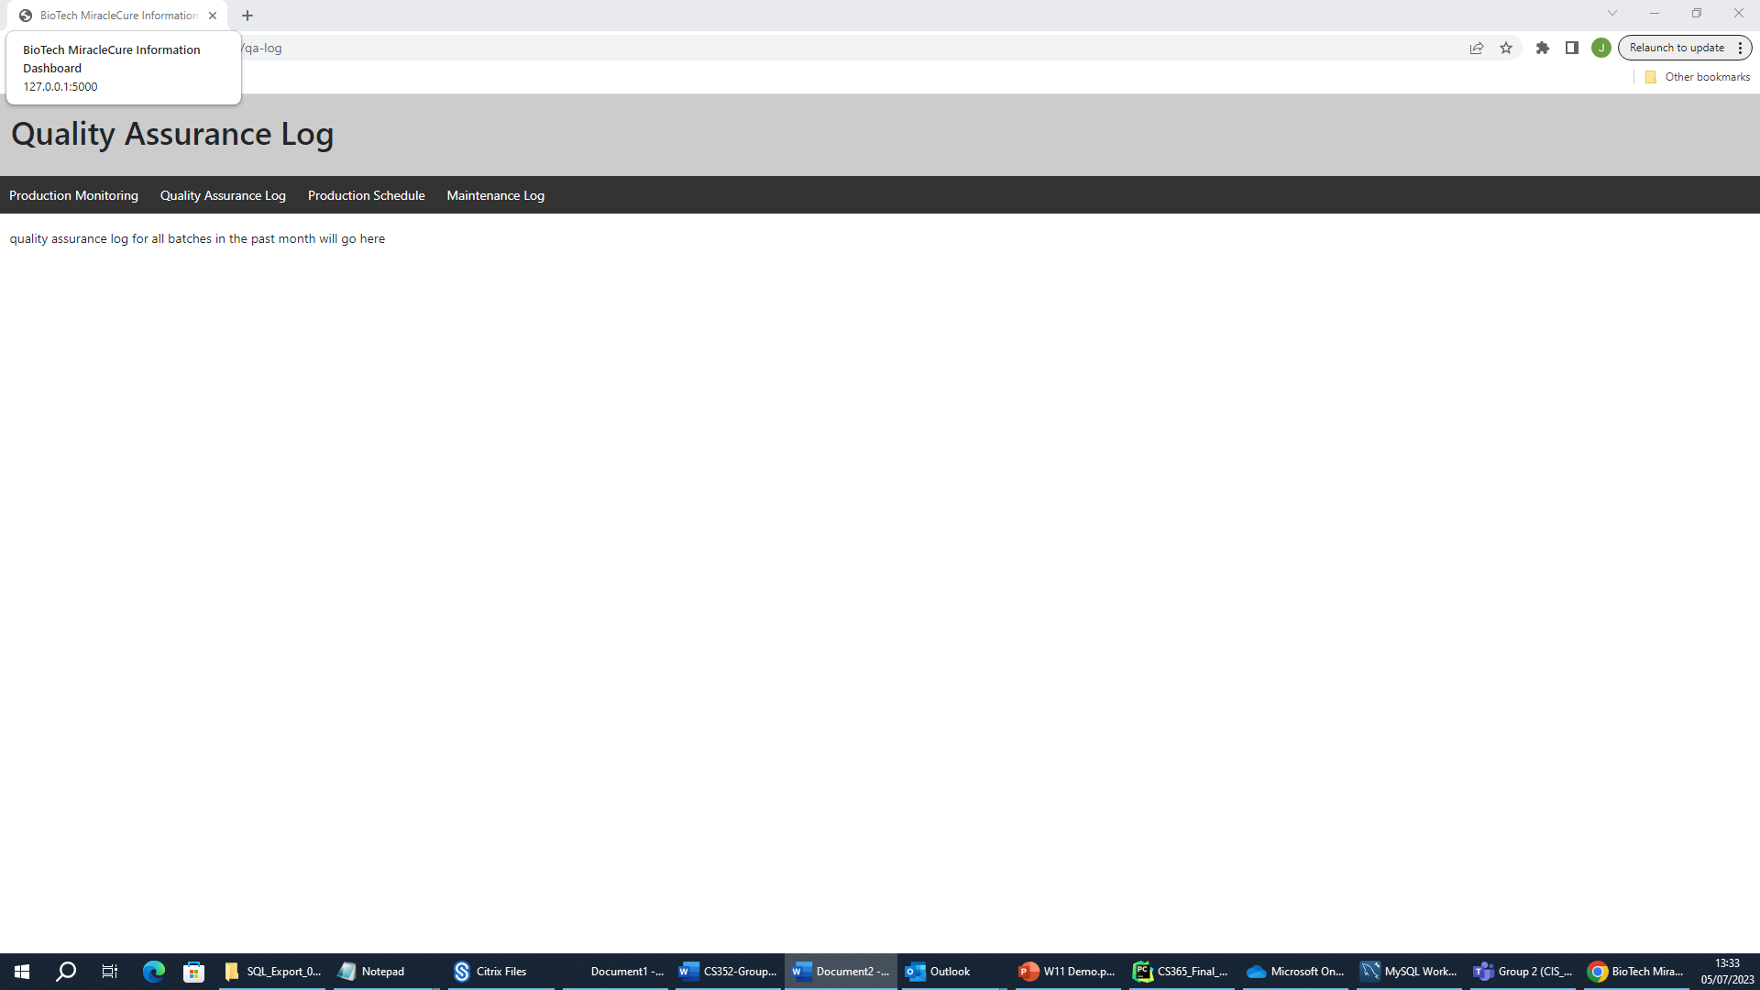

## Production Schedule

The production schedule page is a calendar which shows all scheduled batches and maintenance on production liones both the past and future, allowing management to view amnd monitor the production schedule better.

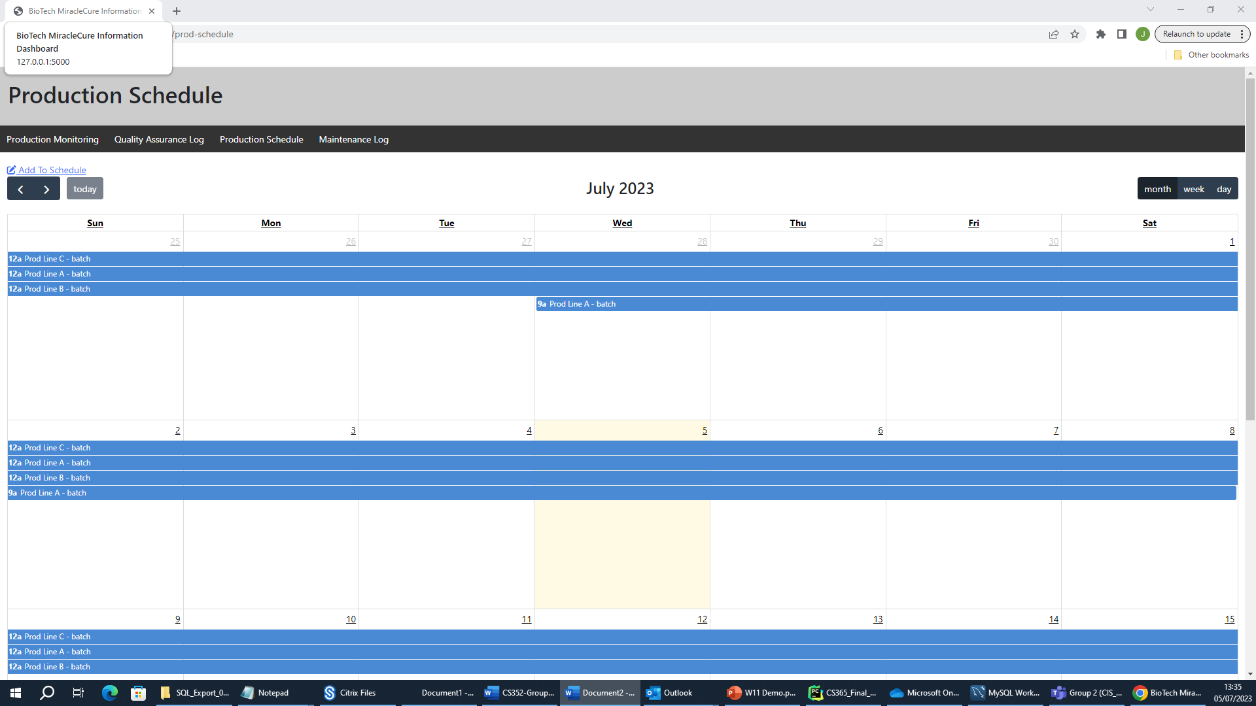

It can be filtered by month, week or day. By selecting from the three options at the top right of the screen as highlighted below.

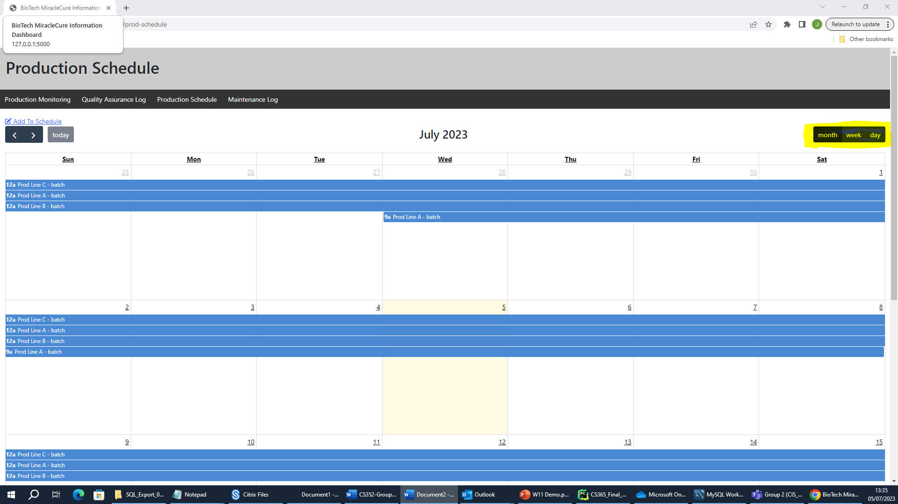

The schedule can also be updated by selecting the “add to schedule“ button as highlighted below.

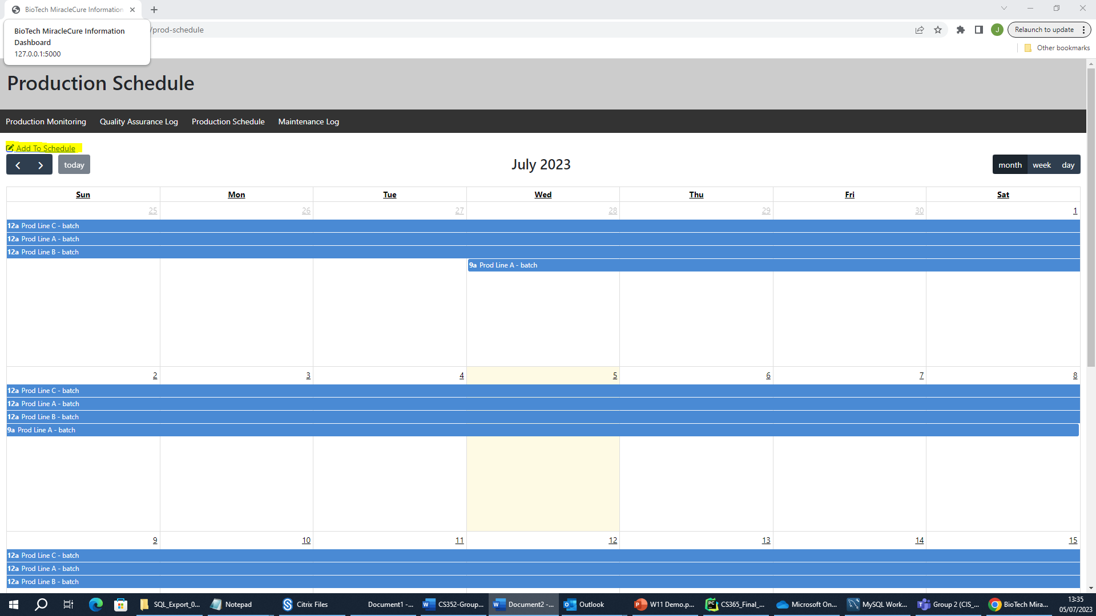

Clicking this displays the following screen prompting for the required information to be input for a given production activity such as the production line, product start time and the expected duration, as well as the type of activity being carried out i.e. a batch production or maintenance.

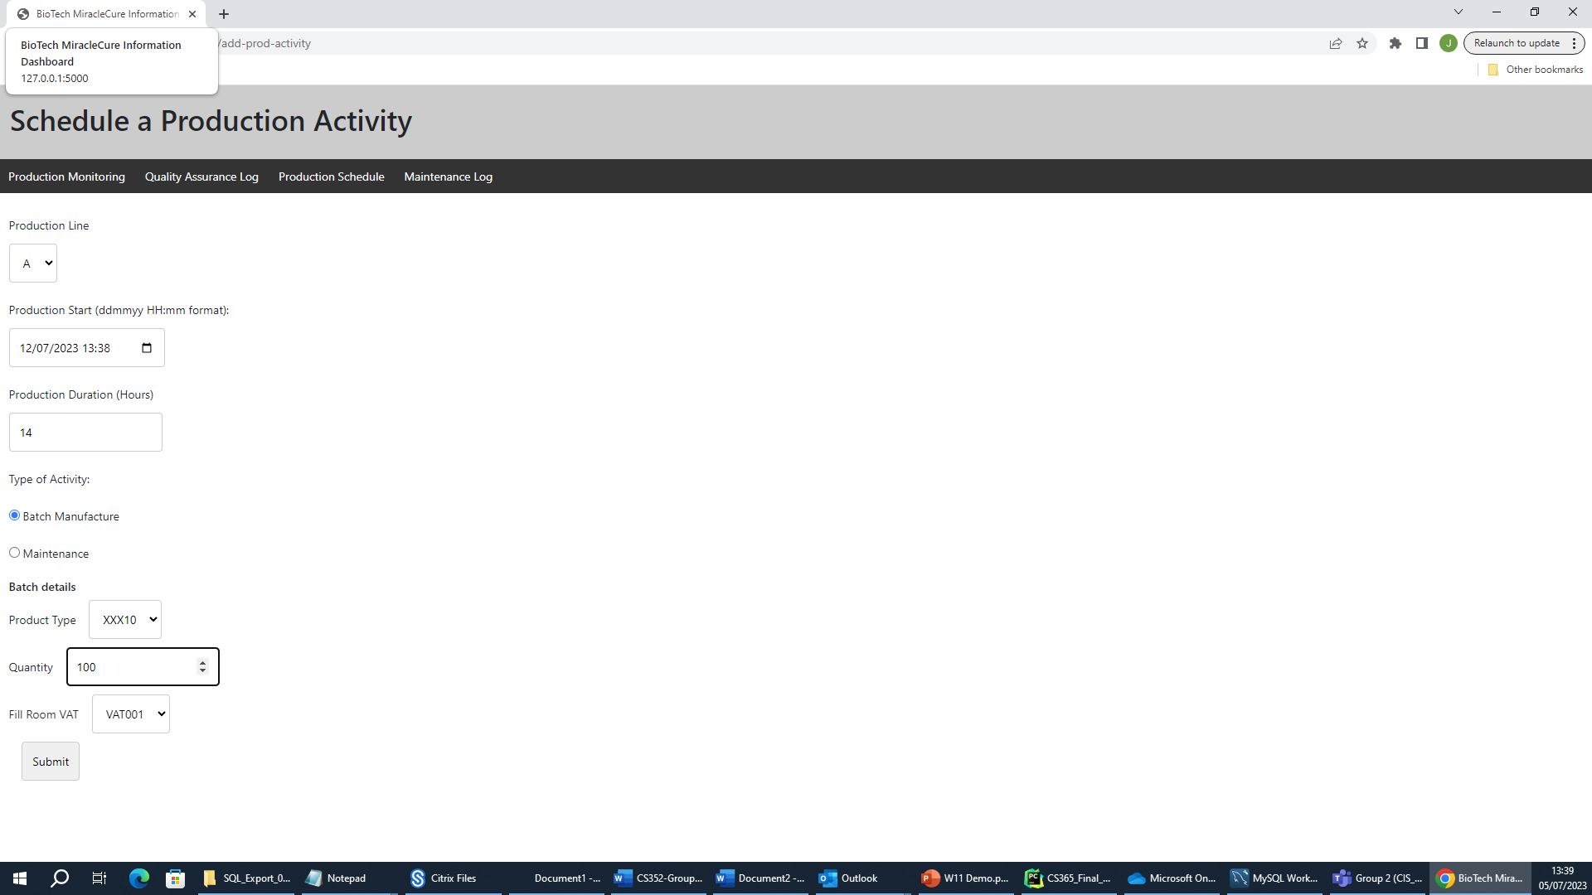

Selecting either batch or maintenenace will prompt for a further set of additional fields relevant to this production activity.

After filling in and submitting the schedule update, it will now display in the production schedule. As is highlighted below.

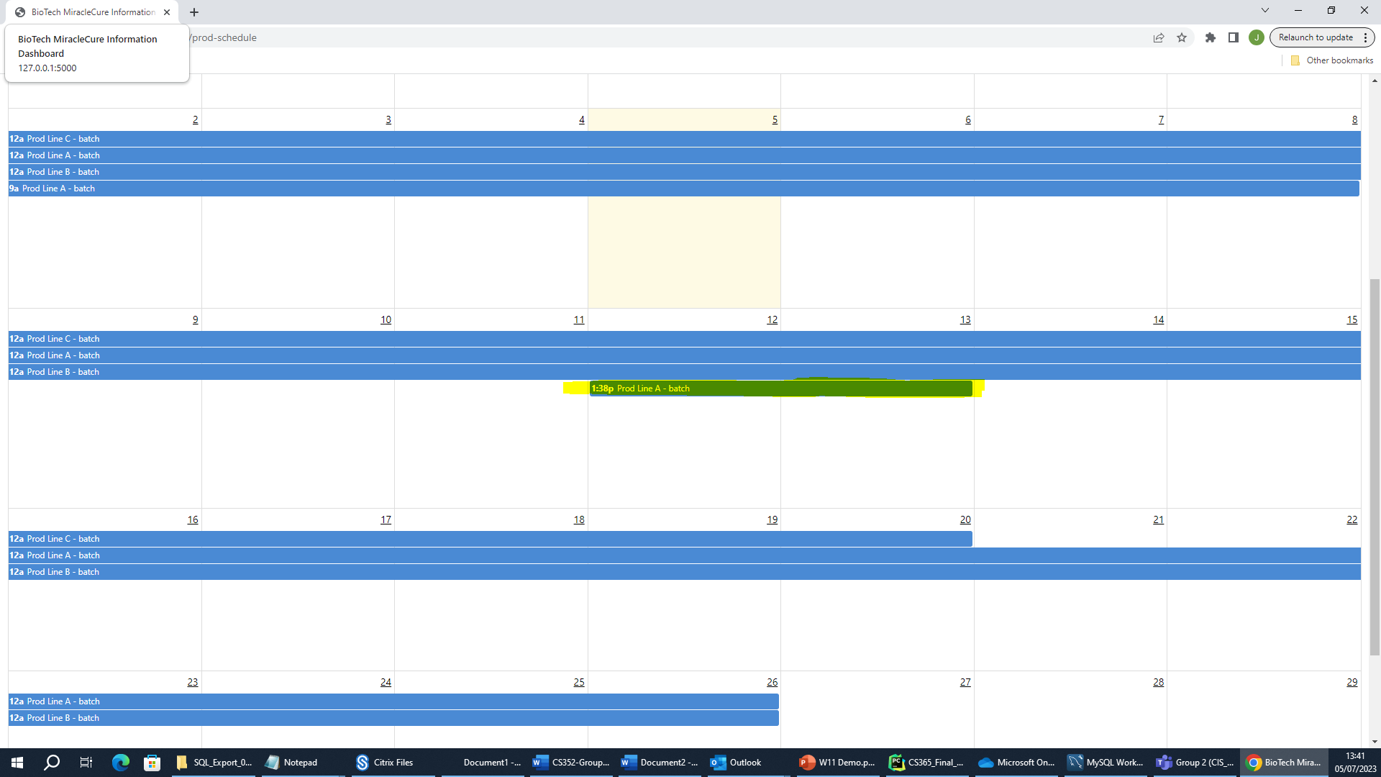

## Maintenance Log

The Maintenance log is also not implemented yet but the intention for this would be to show all maintenance carried out on production lines within the past yeart with some analysis of commonly failing components.

